The carbon footprint analysis of producing styrene from organic waste

The aim
We are facing an huge increase in global population, from the current world population of f 7.6 billion to an expected 9.8 billion in 2050. This projected increase in global population leads to an increase in both food and energy consumption, which in turn in is associated with an increased emission of greenhouse gasses. Right now, we live in a plastic generation. The global production and consumption of plastics have been on the rise for over 50 years now, reaching a plastic consumption of 297.5 million tons by the end of 2015. Plastic products from the petrochemical industry have a high carbon footprint (Boonniteewanich, Pitivut, Tongjoy, & Lapnonkawow, 2014). The combination of global population increase and a mass consumed non-eco-friendly product, in the form of petroleum-based plastics, could be disastrous. This is one of the reasons that the Groningen iGEM team’s project attempts to produce (bio)styrene, a building block for many plastics, from cellulose as an alternative to substitute the petroleum-based styrene. In this section we have carried out a partial Life Cycle Assessment (LCA) to identify the environmental impact of both petroleum-based styrene and bio-based styrene. The main purpose is to provide an insight of the environmental burden that is caused by the worldwide styrene industry in terms of carbon dioxide equivalent emissions (CO₂-eq) and to showcase our greener alternative.

For our LCA analysis we have used the Dutch GER-Values. These values are used for a ‘cradle to gate’ analysis and include all emissions that are needed to produce a certain product. These processemisions of the products do exclude any carbon fluxes from or to the atmosphere. In case of a bio-based feedstock this is a complete analysis because the carbon uptake is balanced with the emissions once the product is disposed. For fossil styrene a value of 3,1 KG needs to be added to this (Croezen & Lieshout, 2015) because these emission will lead to a net carbon emission. (see figure 1) (Croezen & Lieshout, 2015). A full LCA should also include other impact categories however it is decided not to include these. The reason for this that we discovered the LCA analysis in a late phase of the project which forced us to simplify the analysis.
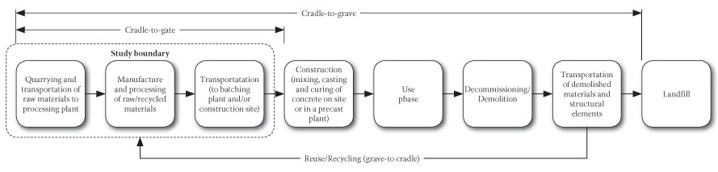
Figure 1. Figure retrieved from: http://www.scielo.org.za/scielo.php?script=sci_arttext&pid=S1021-20192013000200001
In order to evaluate the environmental impact of the two ways of producing styrene, we met with multiple experts from the University of Groningen, and with experts from various startups and companies. First of all, Tjerk Douma, a master student whose specialized in sustainability and did a major part of the analysis. We also met with prof. dr. F. Francesco Picchioni, of the University of Groningen, head of the Product technology department - Engineering and Technology Institute Groningen. Moreover, we met with the start-up companies BioBTX and Zernike Advanced Processing and the companies CE Delft and Avantium.

Analysis
For our analysis, we compared the process of producing styrene from a bio-based feedstock to the process of producing styrene with petroleum as a feedstock. To define the cradle to gate emission of petroleum-based styrene we contacted two experts of the company CE Delft, the authors of a report stating the Gross Energy Requirements values (GER) of industrial feedstock (Croezen & Lieshout, 2015). With their expert help, we were able to define the cradle to gate emission of petroleum-based styrene for our analysis, the value being: 7.8 CO₂-eq per kilogram styrene.
Now we need to compare the GER of petroleum-based styrene with the GER of our StyGreen. In order to do this we need to define the GER of StyGreen. The first step in defining the amount of CO₂-eq per kilogram StyGreen is, defining the feedstock that is going to be used. We explored many different feedstock options (link http://2018.igem.org/Team:Groningen/Applied_Design#source). After comparing all possibilities, we decided to use recycled toilet paper. The main reason for this choice was the sustainability aspect. Toilet paper is product that is not used for anything at this moment. Therefore, it does not hold much monetary value at all, or it holds even negative monetary value. Which means that we can potentially add value to the life-cycle of toilet paper. Another reason for choosing toilet paper, is that we do not want to compete with the food industry. It might be feasible to use sugar, or first generation resources to produce styrene, but this does not fit into our view of a better world.
The second step was to calculate the carbon footprint of recycled toilet paper. The carbon footprint of a feedstock in a certain phase of the Life-Cycle analysis is proportional to the monetary value the feedstock holds in that particular phase. Since the recycled toilet paper is derived from paper, we looked into the monetary value of recycled toilet paper in combination to the resource, paper. After this we looked at the price of the toilet paper, and compared to the price of wood. This way, we could make a parallel to the toilet paper CO2-eq. The cradle to grave carbon emission of paper is 0.9 CO2-eq per kg paper (Croezen & Lieshout, 2015; figure 2 gives a visual representation of the factors determining the carbon emission of paper feedstock).
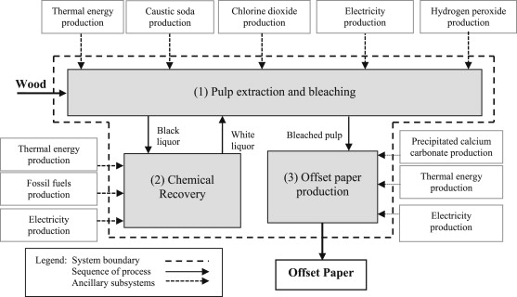
Figure 1. Life cycle assessment of offset paper production (Silva et al., 2015).
The cost of paper is €150 per ton. Due to the fact that toilet paper recycling is still in its infancy, it was hard to define the representative price for this resource. However, after talking to several experts(see/link IHP (Porter)), we came to a price estimate of €15 per ton. Since, toilet paper holds 10% of the monetary value of paper, we divided the CO2-eq by 10 as well, giving our recycled toilet paper feedstock a carbon footprint of 0.09 CO2-eq per kilogram.
Table 1. The carbon emissions of our feedstock, recycled toilet paper.
Feedstock | Price (€ per ton) | Conversion factor | Emissions (CO₂ per kg)
Paper | 150 | 90% | 0.9
Recycled toilet paper | 15 | 10% | 0.09

Next we need to know how much energy (and therefore, how carbon emissions) is required to produce 1 kilogram of StyGreen. The energy requirement is based on the following formula (see table 2):
$$Energy requirements=(\left(b-c-d\right)*\left(b*0.5\right)+(\left(b-c-d\right)*f*i)$$
From the energy requirements we can now derive the process emissions in CO₂ per kg StyGreen by means of the following formula (see table 2):
$$Process emissions=\frac{\left(\left(\frac{energy requirements}{g}\right)*i\right)}{j}$$
This brings us the a process emissions of 1.229 CO₂ per kg produced StyGreen. If our genetically engineered yeast had a 100% conversion rate, we would need 10 kilograms of recycled toilet paper to produce 1 kg of StyGreen (based on the theoretical maximum yield). Which would mean that the carbon footprint of our StyGreen would be 2.129 CO₂-eq per kg.
Table 2. The predicted process emissions of producing StyGreen in our bioreactor.
Process assumptions
(a)Size of our bioreactor (in liters) |  | 500
(b)Heating of water (per degree per 1000 liter/MJ) |  | 4.19
(c) Temperature in bioreactor (in degrees Celsius) |  | 30
(d) Ambient temperature (in degrees Celsius) |  | 10
(e) Contribution exothermic reaction |  | 10
(f) Heat loss (per 24 hour per degree in MJ) |  | 0.03
(g) Calorific value of natural gas (m3) |  | 32
(h) Natural gas (CO₂/m³) |  | 1.8
(i) Process time in bioreactor (in days) |  | 3
(j) KG Styrene per bioreactor |  | 1
 | Energy requirements (MJ) | 21.85
 | Process emissions (CO₂ per kg) | 1.229

This is a lot better than 7.8 CO₂-eq per kg for petroleum-based styrene. However, at this point in time our conversion are not yet 100%. For each kilo of styrene we produce, we need 263 kilograms of cellulose (recycled toilet paper) right now [link flux model]. This would result in 24.89 CO₂-eq per kg, which is way worse than regular (petroleum-based) styrene. This partly due to the assumptions made in the flux model, which assumes that yeast needs have a net biomass gain at all times. While, that is not necessary in our bioreactor. Moreover, the first version of our yeast is just a proof of concept. There are still a lot of parts that can be optimized. Both in the yeast strain itself, in the form of knock-outs, and in the bioreactor, by reducing the process emissions.

Conclusions
- Toilet paper waste is used as the primary raw material in the biorefinery to produce styrene.
  - A feedstock that is not used for feeding humans
  - To which we are able to add value
- Currently the process is not sustainable (based on flux model, with mass balance of 263 : 1)
- We could still optimize our process a lot, so we should be able to decrease the mass balance by a lot. And starting from a mass balance of 33 : 1 we are cleaner than petroleum-based styrene
- We can also improve the process emissions, lower process emissions means our mass balance can be higher (at the moment the process emissions are more than 28% of the total emissions of petroleum-based styrene).

References
Boonniteewanich, J., Pitivut, S., Tongjoy, S., & Lapnonkawow, S. (2014). Evaluation of Carbon Footprint of Bioplastic Straw compared to Petroleum based Straw Products. Energy Procedia, 56, 518–524. https://doi.org/10.1016/j.egypro.2014.07.187
Croezen, H. J., & Lieshout, M. van. (2015). Handleiding CO2-waarden voor biobased grondstoffen volgens MJA3/MEE-methodiek. CE Delft, 73.

Data retrieved from: https://www.un.org/development/desa/publications/world-population-prospects-the-2017-revision.html
Data retrieved from: http://www.worldwatch.org/global-plastic-production-rises-recycling-lags-0
Data retrieved from: http://www.joostdevree.nl/shtmls/warmtestroom.shtml

